83038: Community Resilience Project in Khyber Pakhtunkhwa and FATA

Annual Progress Report
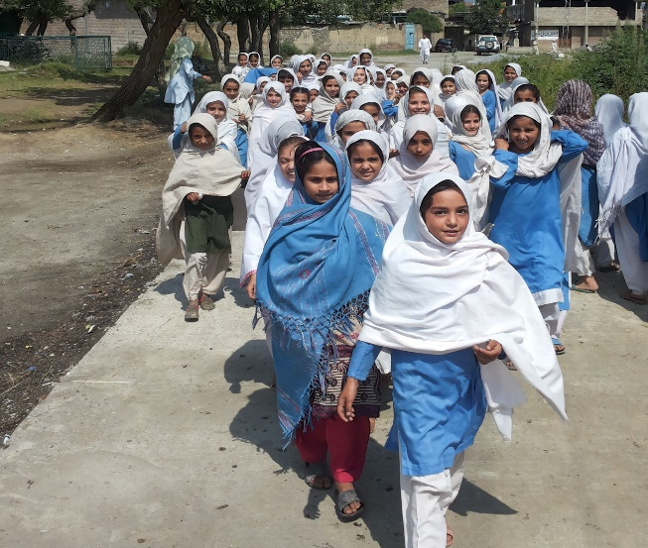
January – December 2014
Photo credits and caption
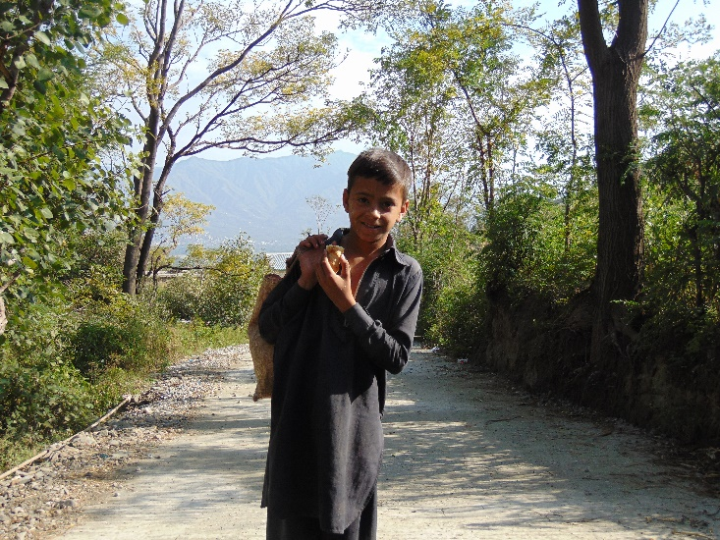

Project Snapshot

Date: |  |  | 31st Dec 2013
Award ID: |  |  | 58104
Project ID: |  |  | 83038
Project Title: |  |  | Community Resilience Project in Khyber Pakhtunkhwa and FATA
Project Start Date: |  |  | 1st Jan 2013
Project End Date: |  |  | 31st Dec 2017
Implementing Partner: |  |  | Selected Construction Firms
Responsible Parties: |  |  | UNDP
Project Budget (all years): |  |  | USD 25 Million
Core Resources: |  |  | USD 3,350,940
Project Brief Description and Outputs:
Community Resilience programme aimed at Vulnerability Reduction, Improved Cohesion and Empowerment in Khyber Pakhtunkhwa and FATA. The programme objective is to develop national and provincial capacities on crisis sensitive programming, community restoration at local level and support social cohesion in crisis affected communities through demand driven peace building interventions. The programme seeks to contribute in improved prevention, risk reduction, and response (Mitigation), and assist to reach development goals including MDG targets for the vulnerable population.
Programme is being implemented in 6 Tehsil of District Swat with 54 community based Infrastructure construction projects such as link roads, Street pavements, bridge, drainage channels and culverts. The FATA component has also been the part of project activities, which is basically on the capacity building of FATA, based grassroots civil society organizations to contribute to peace and development in FATA region.
Project Outputs

Output 1: Social capital strengthened for peace building and social cohesion

This output revolves around the theme of social cohesion for the peace building at local and regional level. For the strengthening of social capital 70 peace and development committees separate for male and female groups(54 male , 16 female) were organized in project areas, in addition to that few matured male committees also integrated at UC level. The peace committees further nominated 80 peace ambassadors/activist within them, who are actively contributing in networking and social cohesion. Peace Mushaira in coordination with district government and local communities was a part of those efforts to reclaim public space for cultural expression, tolerance and to provide a platform to common masses, activists, academicians and authorities for social interaction and peace building

Output 2: Damaged social services structure restored/Rehabilitated

In the backdrop of 2009 military operation in Swat followed by 2010 flood, a huge displacement and devastation was seen in the Malakand division. In 2011 Early Recovery Working Group under the leadership of district government identified 953 communal schemes which required urgent rehabilitation work. UNDP on the request of government of Pakistan with the financial assistance of SFD (Saudi Fund for Development, Kingdom of Saudi Arabia) rehabilitated total 585 schemes including link roads, street pavements, culverts, small bridge and Drainage Channels) during 2012 and 2013. As a third phase of work in 2014 total 54 schemes were planned to rehabilitate. For that purpose private contractors have been hired for different clusters of project locations. So far 38 Schemes have completely been rehabilitated, 5 schemes are 90 % completed and rest of the schemes are underway which delayed due to the reasons shared ahead in the report.

Output 3: National Capacity for conflict sensitive programming, early recovery and gender sensitivity strengthened.

Under output three a consortium of FATA based grassroots CSO was facilitated to develop their consortium, and registered with FATA social welfare. The aim was to develop their capacity to win, design and implement projects for FATA for the peace and development.In this regard FATA consortium CSOs were given trainings on gender sensitivity, conflict analysis tools and also in proposal writing, monitoring and financial management of projects.

Output 4: Implementation Plan developed for reintegration of Ex-Combatants into mainstream social strata and some initiatives piloted.

Under this output a study in Swat have been carried out. The findings of this study have a clear implementation plan for the reintegration of ex-combatants. The process of resource mobilization and partnership is underway to run pilot project in this regard.

An effective Monitoring system is in place to ensure the quality and accountability in design, planning and implementation of project activities. Monitoring team regularly visits field to assess the progress and quality of interventions. Beneficiary participation and stakeholder engagement is considered as integral part of program planning and implementation. Regular consultation and coordination was held with PDMA/PARSA, district administration, public representatives, local communities and other stakeholders to incorporate their experiences, feedback and opinions in program implementation.
Overall Project Quality Rating (mark on the scale of 1 to 5 as per the following criteria):
Exemplary (5)  ***** | High (4)  **** |  |  | Satisfactory (3)  *** | Poor (2)  ** | Inadequate (1)  *
All outputs are rated High or Exemplary | All outputs are rated Satisfactory or higher, and at least two criteria are rated High or Exemplary |  |  | One output may be rated Poor, and all other criteria are rated Satisfactory or higher | Two outputs are rated Poor, and all other criteria are rated Satisfactory or higher | One output is rated Inadequate, or more than two criteria are rated Poor
Budget 2014 |  | US $ 3,350,940
Expenditure 2014 |  | US $ 2,411,941
Delivery % |  | 72 %

Contents

- Introduction

- Situation Analysis

- Project Performance and Results
  - Contribution toward Country Programme Outcome
  - Achievement of Project Results/Outputs

- Lessons Learnt

- The Way Ahead/Key Priorities for 2015

Annex 1: AWP Based reporting matrix
Annex 2: Annual Project Quality Assurance Assessment
Annex 3: Success Stories

Acronyms

CCPAP Common Country Programme Action Plan
CBI Community Based Infrastructure
CSO Civil Society Organization
POC Project Oversight Committee
KP Khyber Pakhtunkhwa
FATA Federally Administered Tribal Areas
FGD Focus Group Discussion
M & E Monitoring and Evaluation
FDN FATA Development Network
PaRRSA Provincial Reconstruction, Rehabilitation and Settlement Authority
PCNA Post Conflict Needs Assessment
UC Union Council
UNDP United Nations Development Programme

- Introduction
In 2009, the military of Pakistan launched operations to eliminate militant groups from their strongholds, including the regions of Buner, Swat, Shangla, Upper Dir and Lower Dir. The operation had immense impact on the socio- economic conditions of the communities residing along the Pakistan / Afghan border, and particularly in the Federally Administered Tribal Areas (FATA) and Khyber Pakhtunkhwa (KP). The devastation and damage to infrastructure and livelihoods was further aggravated by the 2010 floods.
In response, UNDP launched the Community Resilience programme aimed at Vulnerability Reduction, Improved Cohesion and Empowerment in Khyber Pakhtunkhwa and FATA. The programme aimed to develop national and provincial capacities on crisis sensitive programming, community restoration at local level and support social cohesion in crisis affected communities through demand driven peace building interventions. In 2011 Early Recovery Working Group under the leadership of district government led study identified 953 communal schemes which required urgent rehabilitation work. 585 community based infrastructure schemes were rehabilitated in series, 207 schemes in 2012 (Phase I) and 378 schemes in 2013 (Phase II). In November 2013, SFD and UNDP mutually agreed to conduct a verification exercise for remaining 368 community based infrastructure schemes included in initial portfolio of 953. An independent consultant firm was taken on board through a competitive process to conduct community based verification and updated assessment of remaining schemes and prepare detailed Bill of Quantities (BoQs) and engineering estimates.
- As a result of this exercise, out of 368 community based infrastructure, 297 CBIs were found still valid for rehabilitation. Hence 71 schemes were already rehabilitated by some other donor/government department. The detailed BOQs and estimates based on government approved rates for 297 schemes were 9.2 million USD. Since the budget programmed for 2014 was 2.4 million USD, so 53 schemes were proposed as rehabilitation target for 2014 (Phase IV). SFD approved the rehabilitation of 53 CBI schemes in May 2014. One more scheme was included in the plan as result of saving from comparative bids from contractors.SITUATION ANALYSIS

The crisis between the militants and armed forces in Swat, Buner, Dir, and Shangla districts of Malakand Division forced over 2.3 million people to leave their homes. To compound these issues, many families abandoned their means of livelihood and during their displacement, accrued debt in order to meet basic needs. In July 2009, after the government regained control, the crisis-affected families were enabled a safe return home through the ‘Naway Sehar’ (Dawn of a New Beginning) project of the government, with the assistance of international humanitarian organizations. However due to a prolonged gap in economic activity, the majority of crisis-affected families lacked basic income-generating options, and the displacements had depleted their minimal savings. Many families lost their source of income due to the destruction caused by the crisis, and upon their return, there were few opportunities for people to meet their day-to-day needs and revive their livelihoods. The magnitude of destruction was massive. Swat district suffered the most infrastructural damage, with some estimates comparing the levels to those witnessed after the 2005 earthquake. With the support of UNDP, a Crisis Early Recovery Initial Needs Assessment (CERINA) was conducted that provides evidence-based information for priority interventions.

This crisis followed by the 2010 floods, caused enormous damage to the economy of Khyber Pakhtunkhwa (KPK); in particular to the agriculture sector. Up to 97 percent of spring crops – mainly wheat but also fruits and vegetables – were lost, as fields ready for harvest were abandoned and became inundated. To compound this dire situation, many livestock – the main asset of rural families – died. An estimated 717,000 large and 726,000 small animals were lost in the crisis area, which represents 37 percent of the total large and small animal population. In addition, a large number of watercourses, terraces and embankments were also damaged, as were many buildings, roads, street, bridges and other infrastructure, including irrigation facilities, schools, hospitals, basic health units, government offices, veterinary hospitals and research facilities were either bombed or looted and vandalized.

The damage to community infrastructure and collapse of the relevant institutions deprived communities’ access to basic services and facilities. Crisis Early Recovery Initial Need Assessment report, Post Crisis Need Assessment report of KP and FATA and Flood Early Recovery Need Assessment report suggest a two pronged approach (i) community based interventions targeting rural areas; and (ii) interventions through local Government/line departments in urban and rural areas. Full community participation with strong community mobilization is also strongly recommended. The report further highlights the importance of immediate restoration and rehabilitation of community infrastructure that will provide an opportunity for peace building within and among the affected communities. The goal of restoration of community infrastructure is to restore community services, functions and processes, bringing them to normalcy.

Project Performance and results

  - Contribution towards Country Programme Outcome
CPAP Outcome:
Vulnerable populations in crises situations benefit from improved prevention, risk reduction, and response (Mitigation), and are assisted to reach development goals including MDG targets

Indicator(s):  Number of affected/eligible populations that have returned to pre-disaster income and production levels within 18 month (obtained from CPAP and project result framework) | Baseline: | Target(s): | Achievement(s):
Description of output level high/outcome level results achieved in 2014:
CPAP Output: Vulnerable community particularly women affected by crises have access to training, entrepreneurship, livelihoods and community infrastructure
Number of crises affected population (Sex disaggregated) with improved livelihoods, economic opportunities, and community infrastructure

The project has contributed in CPAP outcome, directly with increased access of 263,596 vulnerable populations on rehabilitated community infrastructure. (Among these 1839 are physically challenged people of all age groups). This community infrastructure such as link roads in far flung areas has indirectly contributed in the access of basic social services like education and health for vulnerable people, and also to market access to sale their agriculture goods, which increased their resilience to risks and to combat poverty also with the support of improved access to the basic services, which in a way is a contribution towards the MDGs as well.
The capacity building of FATA CSOs and development of implementation plan for ex-combatants into mainstream society are also the initiatives which may bring peace and development for the vulnerable population in crises affected areas of FATA and KP
Means of Verification
Monitoring reports and success stories.
Impact study is planned which in detail see the impacts of project interventions in Swat.

  - Progress towards Project Results/Outputs

Project Output I:
Social capital strengthened for peace building and social cohesion

Indicator(s):  • Numbers of Peace and Development Committees (COs) formed and strengthened  • Number of Peace and development committees integrated at Tehsil level  • % of Peace ambassadors/Activist able to actively participate in Peace and Development interventions |  | Baseline:  30 PDCs in 2013  0 % |  | Target(s):  Establish of 54 PDCs (30 % women in 2014)  30 % of formed PDCs in 2014  30 % of identified Peace Activist in 2014 |  | Achievement(s):  70 PDCs formed and strengthened in 2014, of which 16 (23 %) are women  39 PDCs (56%) integrated at Union Council  80 Peace Activists identified in 2014 in which 50% are actively participating in peace and development intervention
Description of output level results achieved in 2014:
Under the output 1 of the project, community mobilization activities were carried out to reactivate and/or constitute community organization and identification of the peace activist. The broad based community meetings were conducted in the targeted area and have proven to be very successful in promoting shared understanding of all community members towards the goal of the project.
An Alami Pashto Aman Mushaira (International Pashto poetry on Peace) was organized with the coordination and support of district administration Swat and PDMA/PaRSA in Saidu Sharif wherein renowned poets from all over Pakistan and Afghanistan participated and spread the message of Peace through their poetry.

Progress against Indicator Numbers of Peace and Development Committees (COs) formed and strengthened
In the reporting period total target was formation and strengthening of 54PDCs in 2014, out of which 70 PDCs formed (54 Male and 16 Female). The target are achieved 100% . . These peace and development committees played positive role in the supervision and monitoring of construction work carried out in the project. In addition to that these committees have nominated peace ambassadors/activist among them who are actively participating in the activities of social harmony, peace building and cohesion in their local context.

Progress against Indicator Number of Peace and development committees integrated at Tehsil level
In 2014, there was target of 30 % peace and development committees integration at tehsil level on the basis of the formed and strengthened PDCs in 2014.During the reporting period 70 PDCs formed and strengthened. The process for the integration at tehsil level have been started. In the initial process PDCs are integration at Union council levels and 39 PDCs have been integrated at union council level. For integration at tehsil level sessions with the PDCs members have been conducted and integration at tehsil level will be completed in 1st quarter of 2015.

Progress against Indicator % of Peace ambassadors/Activist able to actively participate in Peace and Development interventions
In 2014, there was target of 30 % peace activist be able to participate in peace and development intervention from total identified Peace activist.80 Peace Activists identified in 2014 in which 50% are actively participating in peace and development intervention.
Overall Output Status (mark the output on the scale of 1 to 5 as per the following criteria):
Exemplary (5)  ***** | High (4)  **** |  | Satisfactory (3)  *** |  | Poor (2)  ** |  | Inadequate (1)  *
The project is expected to over-achieve targeted outputs and/or expected levels of quality, and there is evidence that outputs are contributing to targeted outcomes | The project is expected to over-achieve targeted outputs and/or expected levels of quality |  | The project is expected to achieve targeted outputs with expected levels of quality |  | The project is expected to partially achieve targeted outputs, with less than expected levels of quality |  | Project outputs will likely not be achieved and/or are not likely to be effective in supporting the achievement of targeted outcomes
Means of Verification
- List of COs Reactivated/ Formed
- List of Project Oversight Committee Members Formed
- Meeting Minutes
- Training Reports
- Monitoring Reports
- List of Peace Activist Identified
- Events Pictures
- Success Stories of Project Oversight Committees

Project Output II:
Damaged social services structure restored/Rehabilitated

Indicator(s):  • Number and Types of Social Services completed  • Number of People including youth, women and disabled benefiting from completed social services infrastructures  • % of people satisfied with rehabilitated social service infrastructures and its contribution to Peace building and social cohesion |  | Baseline:  Damaged 953 in 2010,  completed 585 in 2013 (279 streets, 135 culverts, 89 drainage channels, 26 link roads, 56 small bridges)  726500 (28 % women ) by 2013  As per impact assessment study 82% community people found satisfied with the quality of construction work being done for restoration and rehabilitation of community infrastructure schemes (link roads, street pavement, culverts, small bridges and drainage channels) by Saudi Fund. |  | Target(s):  250 in 2014  22500 people (40% Women) in 2014  20 % increase from the Baseline Value |  | Achievement(s):  Re-verification and Designing of 368 Schemes were carried out in 2014. Based on available fund SFD approved 53 CBI schemes budget. Later on one more schemes was added thus reaching the total numbers to 54. Construction and rehabilitation work of these 54 CBI schemes have been started in 2014. 38 schemes are completed so for work on 10 is in progress. While work on the remaining 6 schemes are yet to start.  263,596 inhabitants including above 29 year age (Male 36250, Female 36802), Youth 18-29 (Male 26748, Female 24865) and Children under 18 Years (Boys 71065, Girls 67865) benefiting. Among these inhabitants 1828 are persons with disability of all age groups.  Impact study is planned to be conducted in 2015
Description of output level results achieved in 2014:
Progress against Indicator Number and Types of Social Services completed
Under output 2, 250 Community infrastructure schemes were targeted for rehabilitation/ construction work, but on the bases of available fund, 54 schemes were proposed to SFD for approval for 2014. Rehabilitation /Construction work of these 54 schemes were carried out through private construction firms/contractors.
Below table show the numbers and types of community infrastructure schemes in four tehsils i.e. Kabal, Matta Sebujni, Matta Khararai and Khwazakhela, District Swat.

Type of CBI Scheme | Total Target of 2014 (in Numbers) | Completed in 2014
Link Road | 40 | 28
Street Pavement | 2 | 1
Small Bridges | 1 | 1
Drainage Channels/ Irrigation Channels | 10 | 7
Culvert | 2 | 1
Total | 54 | 38

Progress against Indicator Number of People including youth, women and disabled benefiting from completed social services infrastructures

259,246 inhabitants including above 29 year age (Male 35700, Female 36302), Youth 18-29 (Male 26298, Female 25515) and Children under 18 Years (Boys 69565, Girls 66865). Among these inhabitants 1828 are physically challenged people of all age groups. These beneficiaries have now improved access to the basic services like health, schools and markets due to which they have greater resilience towards poverty and crisis.

Progress against Indicator % of people satisfied with rehabilitated social service infrastructures and its contribution to Peace building and social cohesion
Impact study is planned and to be conducted in 2015 to measure the progress

Overall Output Status (mark the output on the scale of 1 to 5 as per the following criteria):
Exemplary (5)  ***** | High (4)  **** |  | Satisfactory (3)  *** |  | Poor (2)  ** |  | Inadequate (1)  *
The project is expected to over-achieve targeted outputs and/or expected levels of quality, and there is evidence that outputs are contributing to targeted outcomes | The project is expected to over-achieve targeted outputs and/or expected levels of quality |  | The project is expected to achieve targeted outputs with expected levels of quality |  | The project is expected to partially achieve targeted outputs, with less than expected levels of quality |  | Project outputs will likely not be achieved and/or are not likely to be effective in supporting the achievement of targeted outcomes
Means of Verification
- Contract Agreement with Contractor Firms
- Terms of Partnership copy with Community Organization and Project Oversight Committees
- Field inspection report of Project Engineers
- Field inspection reports of Senior Construction Manager and management
- Field Visit Record of Social organizers
- Field Monitoring Reports of Monitoring Team
- Monitoring Report of PaRRSA /PDMA KPK for quality assurance
- Work Completion Report by Project Engineers
- Satisfactory Work Completion certificate by Community organization and Project Oversight site committees
- Before, During and after pictures of construction work
- Success stories

Project Output III:
National Capacity for conflict sensitive programming, early recovery and gender sensitivity strengthened
Indicator(s):  • Conflict and gender sensitized programming documents such as UNDAF, CPAP, Program/Project document early warning, Conflict Monitoring System and capacity in CO  • At least 3 Capacity Building training on Peace Building and social cohesion for Networks  • Peace building and social cohesion promoted through CSO networks |  | Baseline:  Currently there is no Government supported CSO network in the targeted areas |  | Target(s):  -CSO network of 15-20 CSOs will be functional by the end of year 2014 in targeted areas contributing to peace building and development  -3 Training  Seed  Funding to FATA CSO Network |  | Achievement(s):  -32 FATA based CSOs Network established and registered as FDN. They are active in applying funds for  -A Consortium namely Community of Practice constituted at CO level  -Formation of Advisory board on peace building is in process  3 training conducted for FATA based CSOs network in 2014.  - Training on Conflict Analysis tools in which 23 Participants (14 Male, 9 Female) participated.  - Training on Proposal writing, monitoring and financial management of projects in which 32 participants (28 male, 4 female) participated.  - Training on Gender sensitization in which 21 participants (17 male, 4 female) participated.  4 FATA based CSOs have started research study on following two thematic area.  - Role of women as agent of peace  - How to re-integrate ex-militant in society  1st Tranche of Seed Funding for the implementation of these proposal has been transferred to CSOs in Dec 2014
Description of output level results achieved in 2014:

Progress against Indicator Conflict and gender sensitized programming documents such as UNDAF, CPAP, Program/Project document early warning, Conflict Monitoring System and capacity in CO:
The consortium of 32 FATA based grassroots CSOs was developed namely FDN (FATA Development Network) and registered with FATA social welfare with the facilitation of the project. The representatives of the member organizations have also been trained on Conflict analysis tools, monitoring and gender sensitization to build their capacity and further utilize in the projects implemented in FATA. The idea behind developing this FATA based consortium of CSOs was to build their capacity to enable them to bring national and international funding in their areas for peace building and community development. The FATA bases CSOs are actively developing their liaison and networking with national and international donors from the platform of FDN to communicate and restore funding for the problems of FATA people.

Progress against Indicator 3 Capacity Building training on Peace Building and social cohesion for Networks:
To enhance the capacity of FDN in term of awareness, attitudes, skills and knowledge of key concepts and analytical tools that can be used in project designing and implementation at organizational level, Community resilience project organized 3 trainings workshops for FDN in 2014. Detail of the training is as follows
- Training on Conflict Analysis tools. 23 Participants (14 Male, 9 Female) participated in the training.
- Training on Proposal writing, monitoring and financial management of projects. 32 participants (28 male, 4 female) participated in the training.
- Gender sensitization. 21 participants ( 17 male, 4 female) participated in the training

Progress against Indicator Peace building and social cohesion promoted through CSO networks:
In order to strengthen the capacity of FATA based CSO, they are awarded small funding to conduct study on following two thematic areas.
- Role of women as peace agents
- How to re-integrate ex-militant in society
These studies will provide them opportunity to have evidence based information on the key issues of FATA to further design and recommend projects for FATA and to develop their strategic plan for FATA. 1st Tranche of the Funding for the implementation has been transferred to these CSOs in Dec 2014. Second and last tranche is planned to be transferred after successful completion of project due in January 2015.
Overall Output Status (mark the output on the scale of 1 to 5 as per the following criteria):
Exemplary (5)  ***** | High (4)  **** |  | Satisfactory (3)  *** |  | Poor (2)  ** |  | Inadequate (1)  *
The project is expected to over-achieve targeted outputs and/or expected levels of quality, and there is evidence that outputs are contributing to targeted outcomes | The project is expected to over-achieve targeted outputs and/or expected levels of quality |  | The project is expected to achieve targeted outputs with expected levels of quality |  | The project is expected to partially achieve targeted outputs, with less than expected levels of quality |  | Project outputs will likely not be achieved and/or are not likely to be effective in supporting the achievement of targeted outcomes
Means of Verification
- CSOs List
- Meeting Minutes
- List of training participants
- Training Reports
- Certificate of registration
- Copy of Micro Capita Grants Agreements

Project Output IV:

Implementation Plan developed for reintegration of Ex-Combatants into mainstream social strata and some initiatives piloted.
Indicator(s):  • Ex-combatants needs to be supported to help them reintegrate into society |  | Baseline:  Ex-combatants study for swat has been completed by consultant.  - FATA study is planned through FATA based CSOs |  | Target(s):  •Implementation plan for reintegration of ex-combatants developed  •Pilot initiative on the recommendation of consultant |  | Achievement(s):  - Ex-combatant study for Malakand division has been conducted by consultant and recommendations are part of the study report. For pilot initiatives networking and partnership is in process.
Description of output level results achieved in 2014:
Ex-combatant study for Malakand division has been conducted by consultant. The implementation plan for ex-combatants is part of the study report. The strategic planning and securing of funds for implementing the pilot projects for study are in process. The piloting of implementation plans will be further build on the complete projects subject to the available funding on that.
Overall Output Status (mark the output on the scale of 1 to 5 as per the following criteria):
Exemplary (5)  ***** | High (4)  **** |  | Satisfactory (3)  *** |  | Poor (2)  ** |  | Inadequate (1)  *
The project is expected to over-achieve targeted outputs and/or expected levels of quality, and there is evidence that outputs are contributing to targeted outcomes | The project is expected to over-achieve targeted outputs and/or expected levels of quality |  | The project is expected to achieve targeted outputs with expected levels of quality |  | The project is expected to partially achieve targeted outputs, with less than expected levels of quality |  | Project outputs will likely not be achieved and/or are not likely to be effective in supporting the achievement of targeted outcomes
Means of Verification:
- Contract agreement with consultant
- Ex combatant report

- Lessons Learnt

In the discourse of lessons learnt the challenges project faced and the best practices which helped during the project implementation in 2014 are included. These are as follows.

- The delays in the procurement process such as the selection and contracting with the construction vendors started in the months of September and culminated inOctober-2014. So the time left for project implementation was only last three months including the month of December which is very cold in Swat and not very appropriate for the construction and concrete work. These three months were to roll out and implement a quality project was the biggest challenge for the staff in field and based in Islamabad. This has been mitigated with frequent field visits from Islamabad and other strategies, but still this time lapse affected the quality of work.

- Since we are not profit making organization, so it’s not always relevant to select those contractors in financial assessment who quoted minimum rates, this year we have faced problem in a similar case, the contractor who quoted the minimum price for construction, has been selected but now when it came to implementation he failed to conduct his assignment with the reason that the rates were even less than current market rates.
- The project Oversight committees from the community organizations to monitor and supervise the construction work impacted mostly positively in bringing ownership, accountability and quality for construction projects in the sites.
- Third party monitoring further strengthened the quality and quality of work by independent means of verification and onsite inspection
- Social mobilization and conflict resolution at community level also contributed to successful implementation and completion of project
- Lack of on-site testing facility delayed and hampered progress and quality
- Peace festival like Poetry and cultural shows had great impact on peace building and social cohesion not in KP and FATA but throughout Pashtun belt in Pakistan and Afghanistan.

- The way forward/ key Priorities FOR 2015

953 community infrastructure schemes were identified in 2011 from the targeted 06 tehsils of district Swat. 585 community based infrastructure schemes were rehabilitated in 2012 and 2013. 54 high impact schemes are planned in 2014, of which 38 are completed and remaining 16 will be completed in first quarter of 2015.
To date 638 schemes were planned to be completed including
A project proposal for SFD has been prepared for remaining 243 schemes. It has also been supported by the impact study of an independent consultant conducted in 2014 which recommended that the communal infrastructure schemes have a lot of positive impact (social and economic) on the lives of local people. The proposal of 243 schemes (for the period of 2015-2016) should be submitted to Saudi Fund for Development and if approved rest of the schemes work will be started in 2015.
Comprehensive impact study is also being planned for 2015 to measure the anticipated and unanticipated changes, communal schemes have brought through evidence based information. This study also aimed to capture the key learning and lesson learned for similar future interventions.

Annex: AWP based Reporting Matrix

EXPECTED OUTPUTS  And baseline, associated indicators and annual targets | PLANNED ACTIVITIES (as per AWP) | Activity Status  Completed, Ongoing, Delayed, Cancelled | AWP Budget ($) | Expenditure ($) | % Delivery
Project Output 1:  Social capital strengthened for peace building and social cohesion  Indicators:  • Numbers of Peace and Development Committees (Cos) formed and strengthened  • Number of Peace and development committees integrated at Tehsil level  • % of Peace ambassadors/Advocates able to actively participate in Peace and Development interventions  Baseline:  30 in 2013  0 %  Targets:  100 (30 % women in 2014)  30 % in 2014 | Activity 1.1.1: Initial Dialog with the Target community | Completed
 | Activity 1.1.2: Formation of PDC/ VO in community and Tehsil Level | Completed
 | Activity 1.1.3: Undertake Peace Walks/ Seminars with communities promoting peace building and social cohesion | Continue | 20,000 | 9,832 | 49 %
 | Activity 1.1.4: Developing capacities of peace ambassadors on peace building, planning, implementation and monitoring of ongoing interventions contributing towards peace building and social cohesion | Continue | 11,084.11 | 5,571 | 50 %
Project Output 2  Indicators:  • Number and Types of Social Services completed  • Number of People including youth, women and disabled benefiting from completed social services infrastructures  • % of people satisfied with rehabilitated social service infrastructures and its contribution to Peace building and social cohesion  Baseline:  •Damaged 953 in 2010, completed 585 in 2013  •726500 (28 % women ) by 2013  • Study is underway for baseline in partnership with UNESCO and WHO  Targets:  • 250 social services schemes will be completed in 2014 benefiting 225,000 people (40% women) | Activity 2.1.1: Community initiative to promote peace and empower communities, including economic recovery and sports for peace. | Continue | 2,443,447.66 | 1,710,565 | 70 %
Project Output 3  Indicators:  • Conflict and gender sensitized programming documents such as UNDAF, CPAP, Program/Project document early warning, Conflict Monitoring System and capacity in CO  • At least 3 Capacity Building training on Peace Building and social cohesion for Networks  • Peace building and social cohesion promoted through CSO networks  Baseline:  • Currently there is no Government supported CSO network in the targeted areas  Targets:  • CSO network of 15-20 CSOs will be functional by the end of year 2014 in targeted areas contributing to peace building and development  • 3 Training  • Seed Funding to FATA CSO Network | Activity 3.1.1: CSOs/LSOs consortium established, strengthened and registered with relevant authorities/Secretariat, contributing to conflict sensitive recovery and gender empowerment initiative | Completed
 | Activity 3.1.2: Design monitoring system to provide inputs to ongoing analysis of the situation and define possible entry points for programming | Completed
 | Activity 3.1.3: Provide technical assistance and improve ongoing programming of the government and stakeholders using gender and conflict sensitive approach | Completed | 30,000 | 19,410 | 65 %
 | Activity 3.1.4: Conduct capacity building workshop for UN, UNDP and national stakeholders in gender, conflict analysis and conflict sensitive early recovery. | Completed
 | Activity 3.1.5: Developed gender empowered strategy in the context of conflict sensitive environment, monitor development trends and build partnership with stakeholders | Continue | 20,000 | 8,849 | 44 %
Project Output 4  Indicators:  • Ex-combatants needs to be supported to help them reintegrate into society  Baseline:  • Ex-combatants study is underway to get baseline information  Targets:  •Implementation plan for reintegration of ex-combatants developed  •Pilot initiative on the recommendation of consultant | Activity 4.1.1: Formation of a UNDP Pakistan approach to peace building through a continues political and conflict analysis, conflict mainstreaming in UNDP programming, reaching UNDAF goals, creating strategic partnership and mobilizing resources | Completed | 101,188.91 | 60,496 | 60 %
TOTAL |  |  | 2,625,720.68 | 1,814,723 | 69 %

Annex: Success Stories:

Success Story 1:
Construction of the link Roads brings changes in the lives of the people indeed
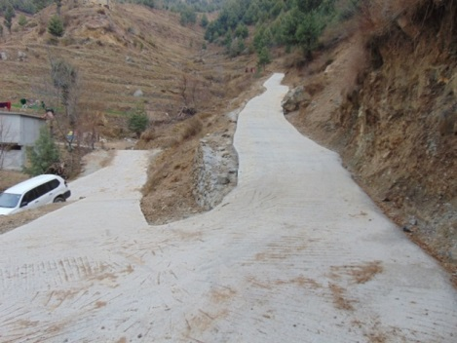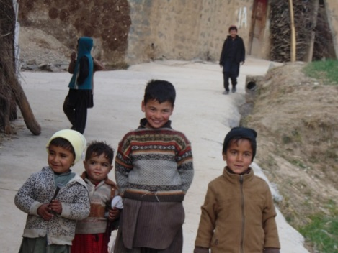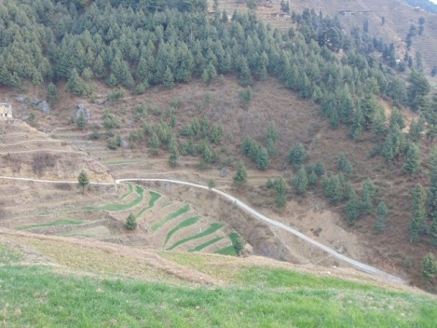
Link Road Dop UC Tall, Tehsil Kabal, District Swat

Dop is a remote village of UC Tall, Tehsil Kabal, Disrict Swat and situated at high altitude of -------meters in the North of the Kabal Tehsil. A main road from Kabal Chowk leading to Dewali, Shah Dheri and Manrhian. A link road from Marani leads to Dop Village. Its distance from Mengora city is 50 Km. the people of the Dop village are very poor and cannot fulfil their basic needs. There is one Government Primary School and Government Gilrs Primary School in the village. Total population of Dop Village is 1200 consisting on 150Households. Dop link road also connects 705 Households (a population of 5640 people) of eight other villages i.e. Gat Jay, Jabba, Shangorhai, Pategram, Band, Ghanam Rangay, Ban Kororho patay and Och Tangay. There is no Basic Health facility in these villages. Marani village is nearby these villages and is using as main market by these villagers.
Before the construction of the Dop Link road, the condition of the road was very bad. The people of the villages travel through walk, sometime only 4x4 vehicle transportation were used but this transportation was very costly and 90% of the population cannot bear the cost of these vehicles. Another problem faced by the villagers arose during the rainy seasons. The low earthen track remained inundated for months thus disconnecting the village from the main city. Due to these bad conditions, transport vehicles were not prepared to come to the village. This made it difficult to transport agricultural produce from the village. Owing to this the people were not cultivating all of their land. Moreover when medical emergencies arose, the people of the village carried their patients on carts or on their shoulders to the nearest metalled road and in rainy season this was a nightmare for not only the patient but also for them, who use to carry him.
UNDP under Community resilience project start the construction of the Link Road Dop in 2014. The construction of the road was carried out through a construction firm. Community was also involved in the construction of the link road. Community Mobilization Team was involved to identify the Community organization and formation of Project Oversight committees for the construction work of Link Road Dop. Under Project intervention Project Oversight committees was established and Trained on monitoring the construction work. All the BOQ, Site map, Detail of construction work and Cost of the schemes were shared with POCs to improve the quality of work and transparency. Total length of the link road was 11000 feet .The construction work of the link road Dop Jaba was initiated on September 15, 2014 and completed on December 5, 2014. The total cost of the project came to PKR. 10406561. The project has now been handed over to the community and is being maintained by local stakeholders.
The completion of the link road has provided a way towards development for the villagers of Dop and Surroundings. Easy and timely access to the market has created a new way of income generation through reduction in time loss. Vehicles such as Pick-Ups, Motor Cars and Motor Cycles have started coming to the village and have thus reduced the transportation cost by 50%. Land value of the area is said to have increased by 50%. In addition the community has now started to change the cropping pattern of an area of over 500 acres adjacent to the link road. By the construction of a link road the people have moved a step forward in reducing poverty, and increasing the potential for better days in the future. Construction of Dop road also improved access of the community to the health and education services.
Paindaman one of the community members of Dop village shared that “Due to the un-paved road and difficult track the access to the health facility was very difficult and villagers were unable to timely reach to the nearest health facility and in case of emergency they used to tie the patients on the cot (charpai) and used to take to the main road which was very difficult for them now due to the rehabilitation of Dop road their access to the health services improved and they timely reach to the hospital in case of any emergency”.
Naik Zada a community member of Dop shared that “before the construction the condition of the road was very bed and it was very difficult to travel on it took over 2 hours from Dop Village to Manai Village and even a donkey cannot easily travelled on it but now the construction of the road has made the life easy for 800 Households of Dop, Jaba and hamlets for travelling specially for 400 school children, who daily travel to the Manai”
Khdimuddin, inhabitant of Dop village, shared his happiness over the construction of the link road, “We are grateful to UNDP and Saudi Government for reconstruction of this road. Before this, women carry fire wood and dry straw on their heads and similarly men carry wheat and maize on their shoulder to the grind mills and it used to take more than one hour and humanly it was very difficult. Now transport access improved and these problems resolved”.

Outcomes describe the intended changes in development conditions that result from the interventions of governments and other stakeholders, including international development agencies such as UNDP. They are medium-term development results created through the delivery of outputs and the contributions of various partners and non-partners. Outcomes provide a clear vision of what has changed or will change globally or in a particular region, country or community within a period of time. They normally relate to changes in institutional performance or behavior among individuals or groups. Outcomes cannot normally be achieved by only one agency and are not under the direct control of a project manager.
Outputs are short-term development results produced by project and non-project activities. They must be achieved with the resources provided and within the time-frame specified (usually less than five years).

